Name : Alveena naz
Reg No. FA25-BSE-010
OOP Lab Task 4

Lab Task 1:
// main class
public class JavaApplication4 {
public static void main(String[] args) {
Distance d1 = new Distance(4,3);
Distance d2 = new Distance(5,7);
Distance d3 = d1.add(d2);
d3.display();
}

}
// Distance class
public class Distance {
private int inches;
private int feet;
Distance(){}
Distance(int i,int f)
{
this.inches = i;
this.feet = f;
}
public void setInches(int i)
{
this.inches = i;
}
public void setFeet(int f)
{
this.feet = f;
}
public int getInches(){
return inches;
}
public int getFeet(){
return feet;
}
public Distance add(Distance d1){
Distance newD = new Distance(inches + d1.inches,feet + d1.feet);
return newD;
}
public void display(){
System.out.println("Inches; " + inches + " Feet:" + feet);
}

}

OUTPUT:
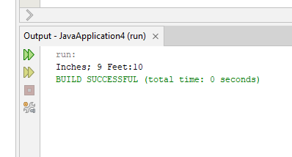

Lab Task 3:
public class JavaApplication6 {
public static void main(String[] args) {
String chapNames1[] ={"A","B","C"};
String chapNames2[] ={"D","E","F","E"};

Book b1 = new Book();
Book b2 = new Book("Alveena",chapNames1);
boolean check = b1.compareAuthors(b2);
if(check)
{
System.out.println(" Both books author are same");
}
else{
System.out.println("Both books author are different");
}
Book b3 = Book.compareChapters(b1, b2);
System.out.println("author name: " + b3.getAuthor());
}

}
// Book class
public class Book {
private String author;
private String chaptersNames[];
Book(){}
Book(String author, String chap[]){
this.author = author;
this.chaptersNames = chap;
}
public void setAuthor(String author){
this.author = author;
}
public void setChaptersNames(String[] chap){
this.chaptersNames = chap;
}
public String getAuthor(){
return author;
}
public boolean compareAuthors(Book b3){
if(this.author.equalsIgnoreCase(b3.author))
return true;

return false;
}
public static Book compareChapters(Book b1, Book b2){
int count1 = 0;
int count2 =0;
for(int i =0;i<b1.chaptersNames.length;i++){
count1++;
}
for(int i =0;i<b2.chaptersNames.length;i++){
count2++;
}
if(count1>=count2)
{
return b1;
}
else
{
return b2;
}
}

}
OUTPUT:
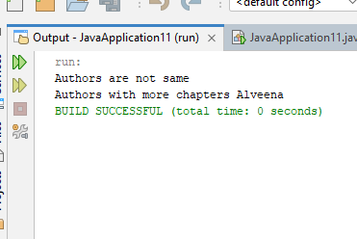

Lab Task 3
// main class
public class JavaApplication5
{
public static void main(String[] args)
{
Fraction f1 = new Fraction(3,5);
Fraction f2 = new Fraction(4,2);
System.out.println(f1.Equals(f2));
}

}
// fraction class
public class Fraction
{
private int a;
private int b;

Fraction(){}

public Fraction(int a,int b)
{
this.a = a;
this.b = b;
}

public void setA(int a)
{
this.a=a;
}
public void setB(int b)
{
this.b=b;
}
public int getA()
{
return a;
}
public int getB()
{
return b;
}
public boolean Equals(Fraction f)
{
if(this.a==f.a && this.b==f.b)
return true;
else
return false;
}
public void display()
{
System.out.println(a + " " + "/" + b + " ");
}
}

OUTPUT:
